Challis Regan

Task 2.5

**Models**

After reviewing my three models, Recipes, Ingredients and Users, I decided to add two more models, RecipeIngredient and Home. RecipeIngredient is for the quantities of the ingredients. I made the separate model to make the individual ingredients easier to search. The Home model is based on the Sales model from the Bookstore app. I named it Home instead of Sales because I am not selling any of my recipes and I am hosting my home.html there. I added a notes field to the Recipes model to add the cooking instructions.

**Frontend Inspirations**

Here are three recipe websites I find aesthetically pleasing and useful. Please note I am using an ad blocker (uBlock Origin) so I am not sure how much white space would be filled with ads.

**Cookie + Kate** [**https://cookieandkate.com/**](https://cookieandkate.com/)

**Home page:** The layout is clean, organized, modern and has nice visuals. The home page is organized by contemporary and seasonal topics, “The Latest”, “Healthy Winter Recipes”, “Dinner Recipes”, etc. Searching for specific recipes or general inspiration is easy because there is a search bar, all recipes menu and browse by category. It is located at the top and there is a more specific search feature when you scroll further down the page.

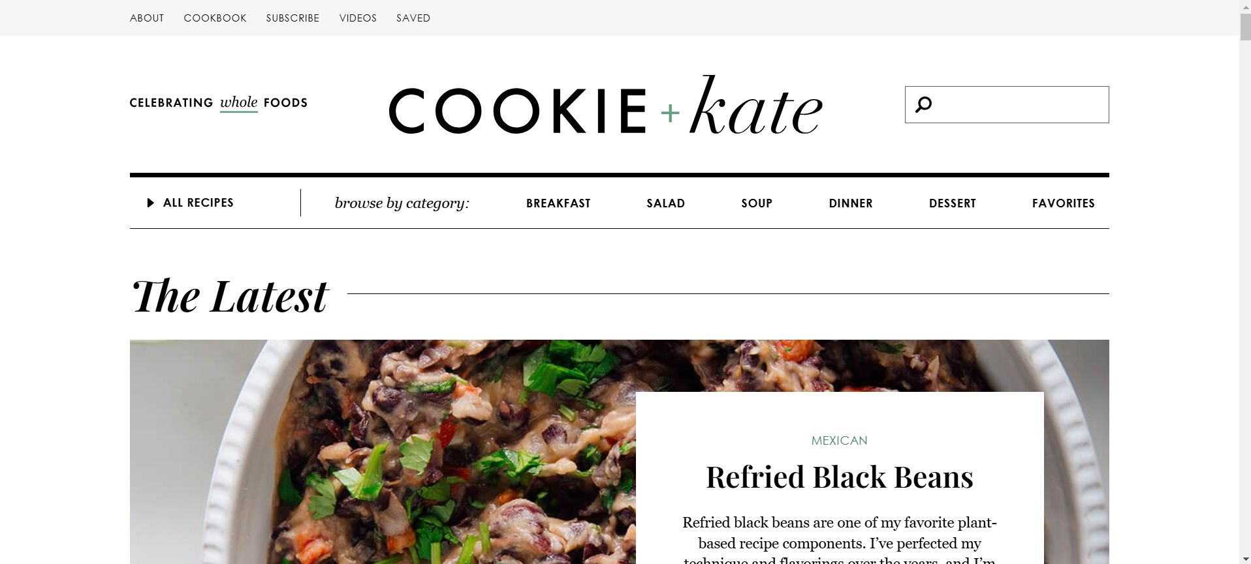

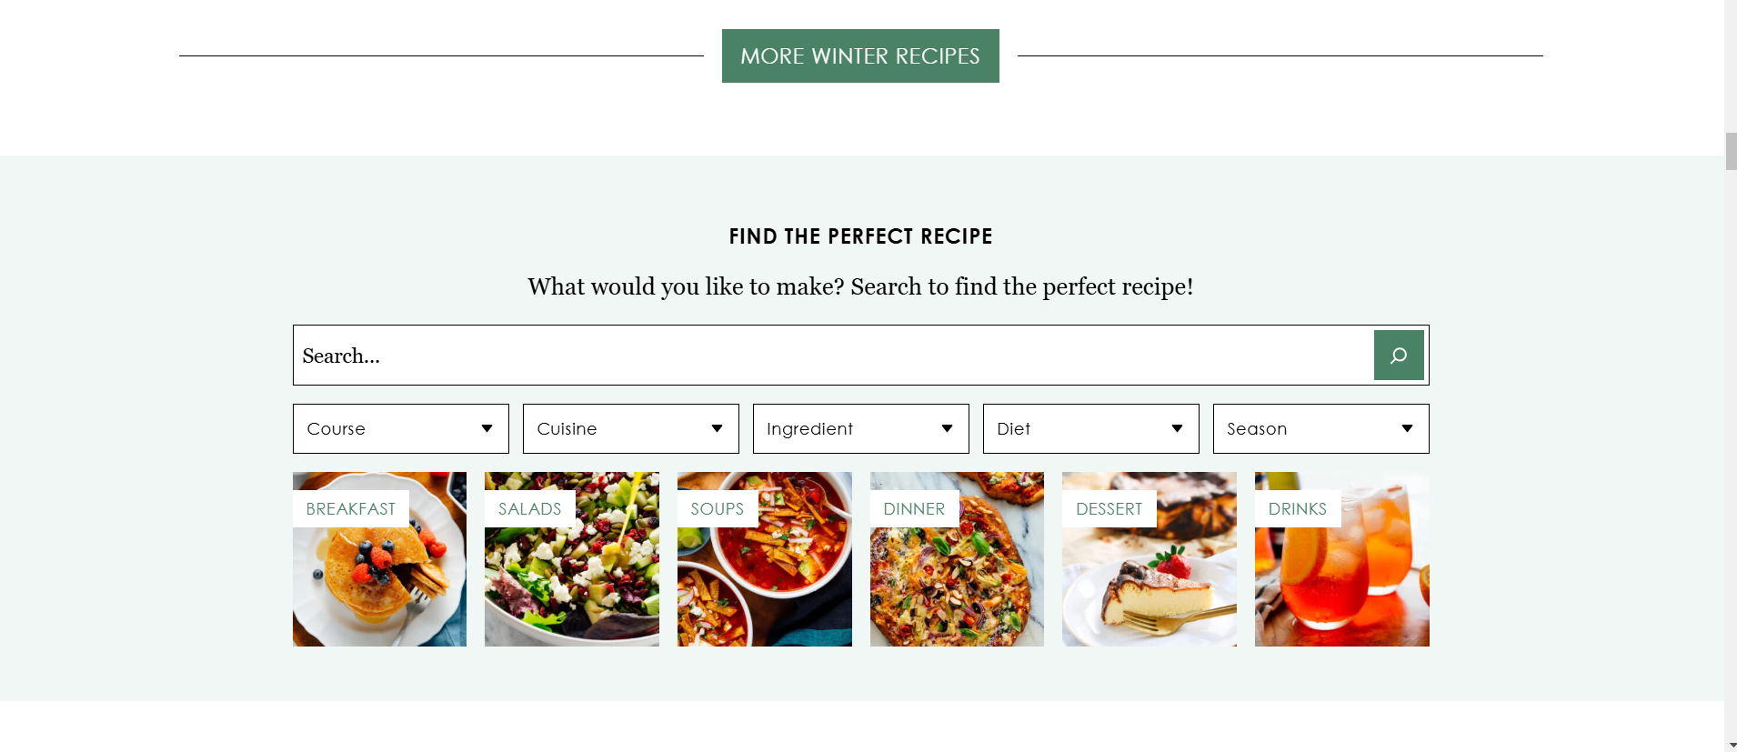

**Recipe page:** The recipe page has a lot of written details and pictures before the actual recipe. Fortunately, there is a jump to recipe button if you want to skip that. Other helpful features include a serving multiplier button and nutrition information. The recipe itself is well-written with clear, numbered instructions.

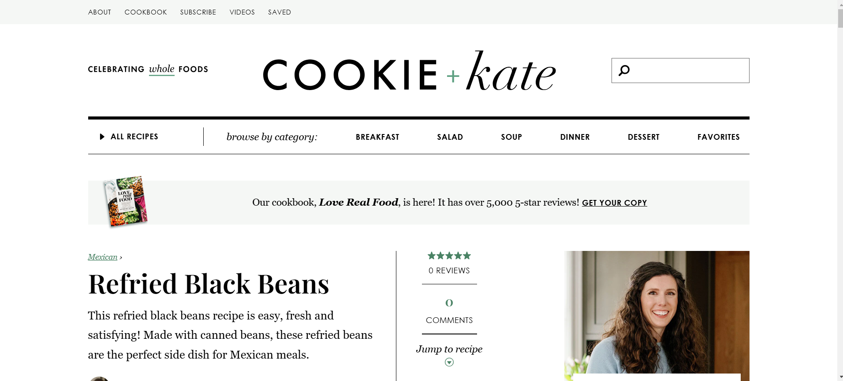

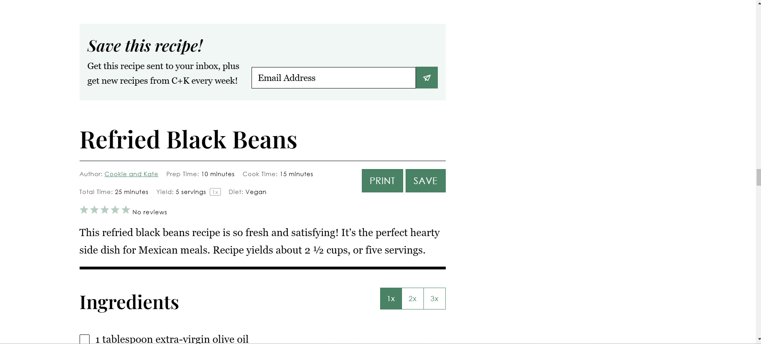

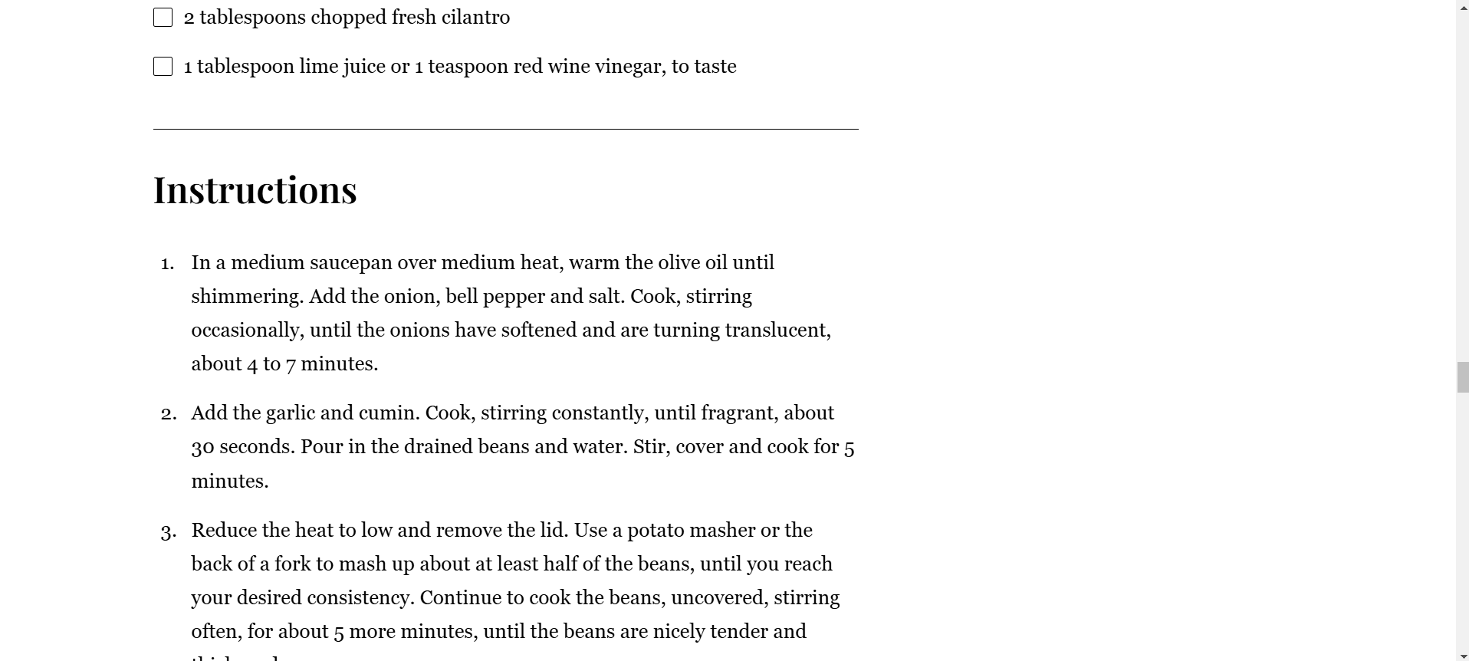

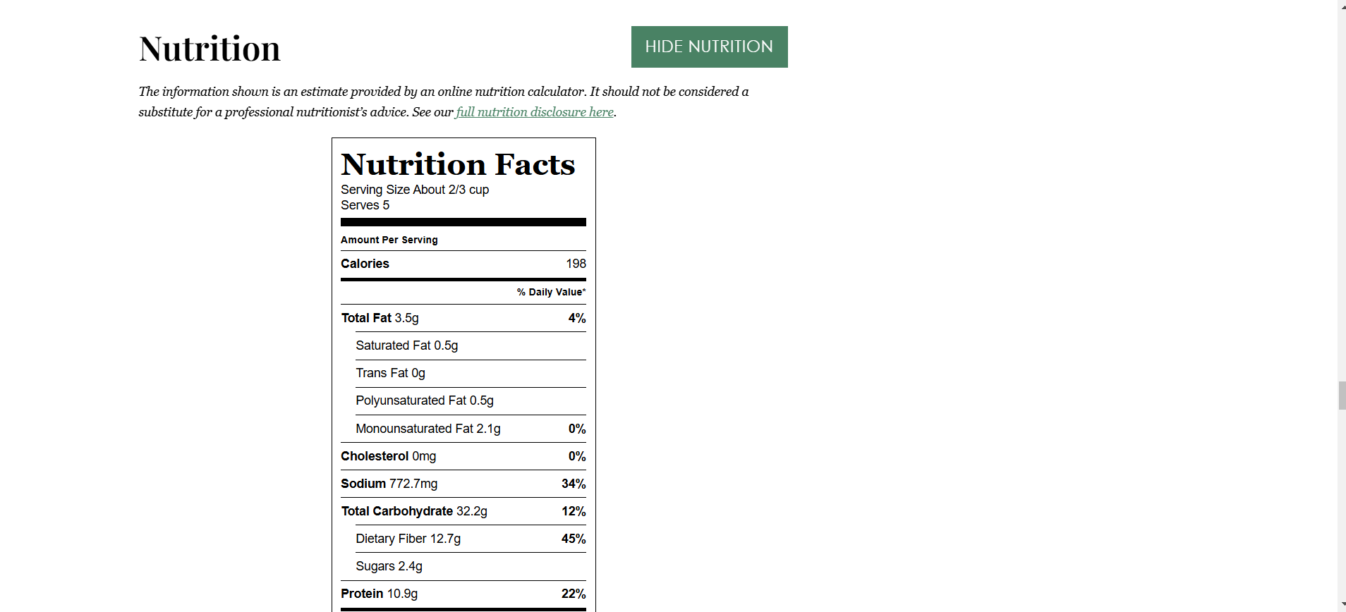

**Just One Cookbook** [**https://www.justonecookbook.com/**](https://www.justonecookbook.com/)

**Home page:** The layout is clean, organized, modern and has nice visuals. The home page shows different categories of Japanese recipes to explore. Searching for specific recipes or general inspiration is easy because there is a search bar, and all recipes menu option on top and a browse by course section further down the page.

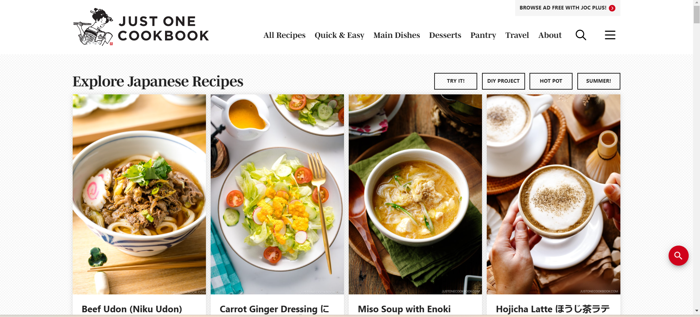

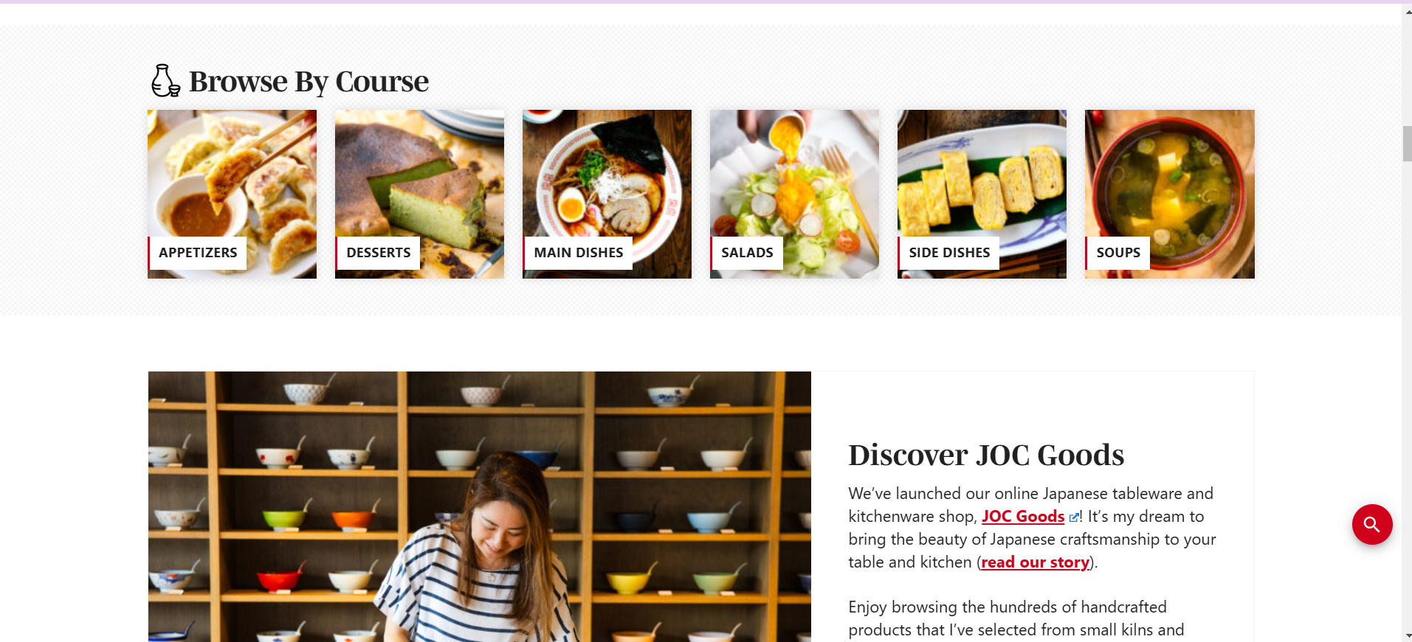

**Recipe page:** The recipe page has a lot of written details and pictures before the actual recipe. Fortunately, there is a jump to recipe button if you want to skip that. There are two different ways to change the serving size, either press the 1x/2x/3x buttons, or slide to change the number next to “Servings” to get more customized measurements. There is a measurement converter from US Customary to Metric. Also, a Cook Mode toggle to prevent your screen from going dark. And a picture toggle button in the recipe instructions. And there is nutrition information. The recipe itself is well-written with clear, numbered instructions.

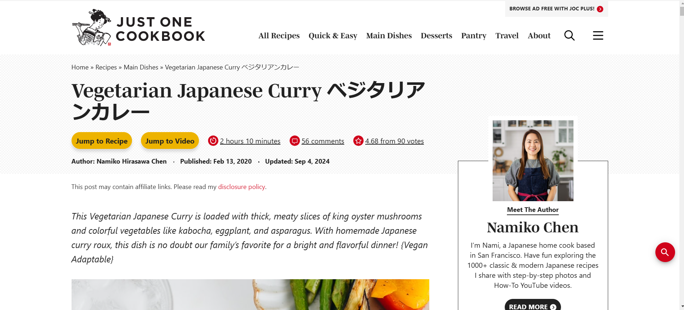

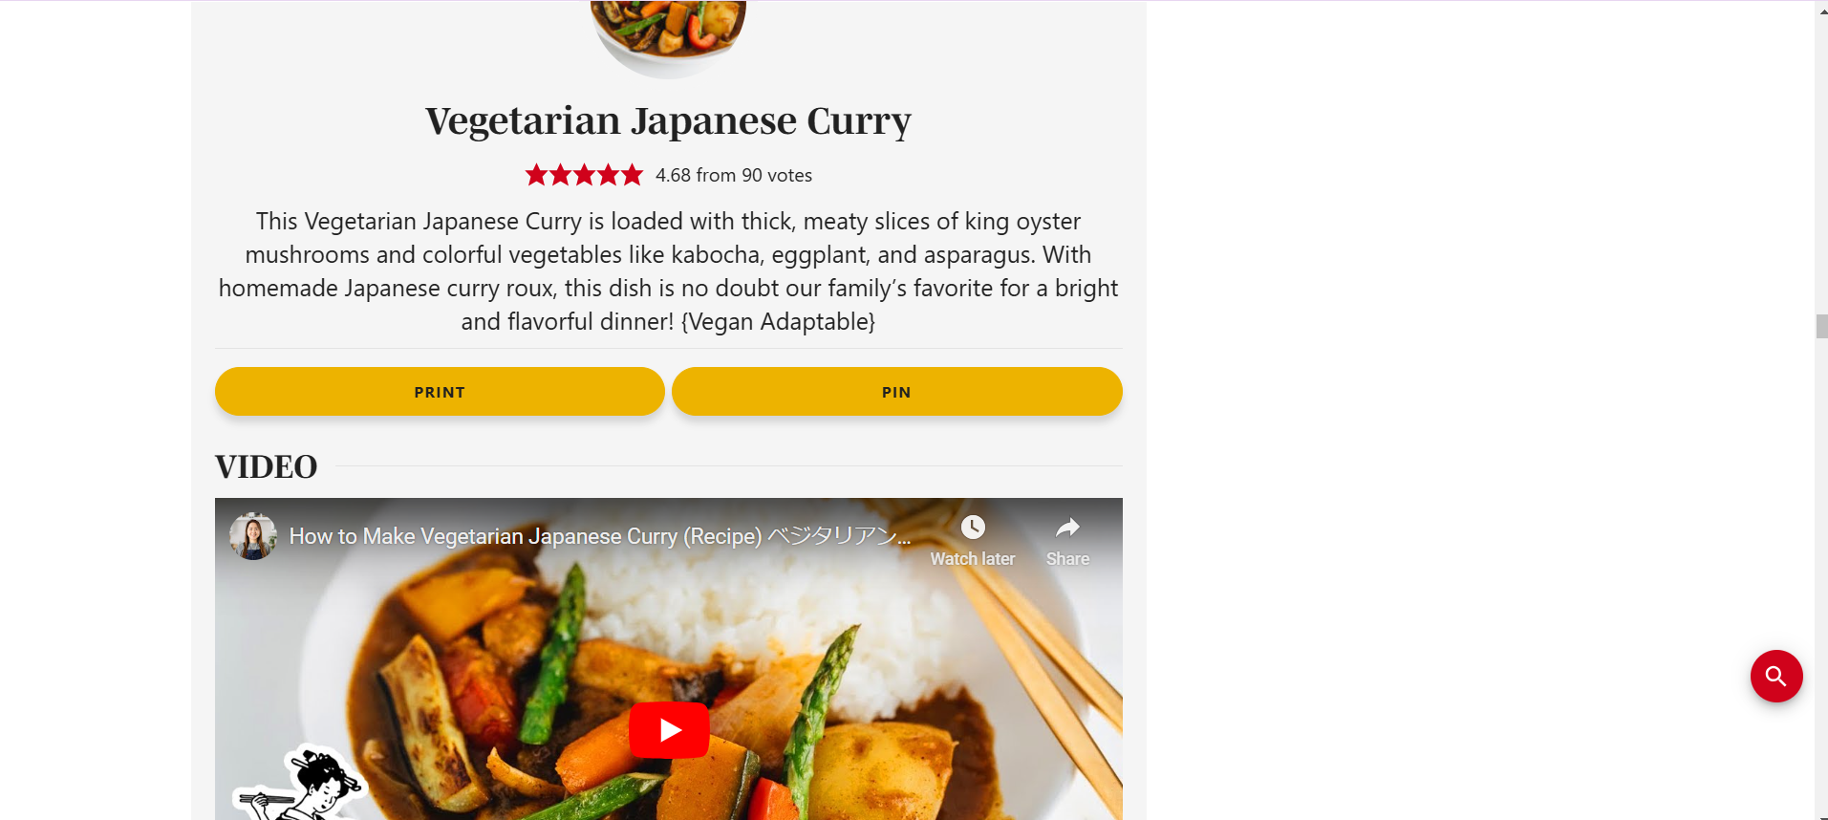

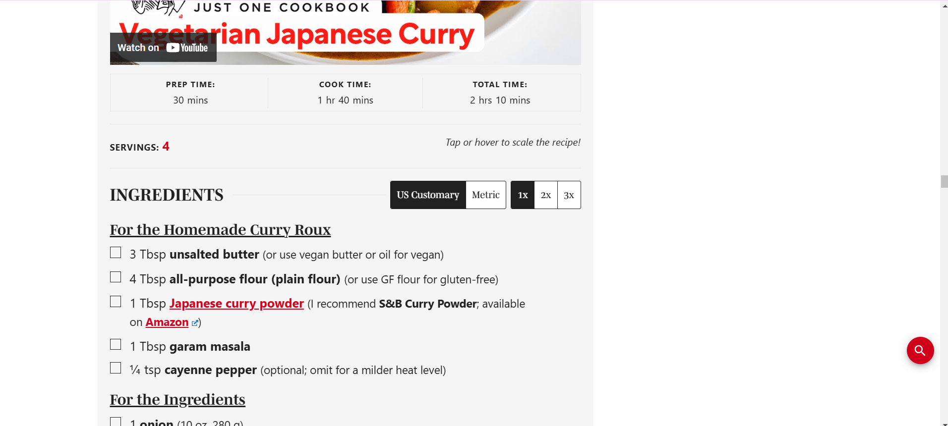

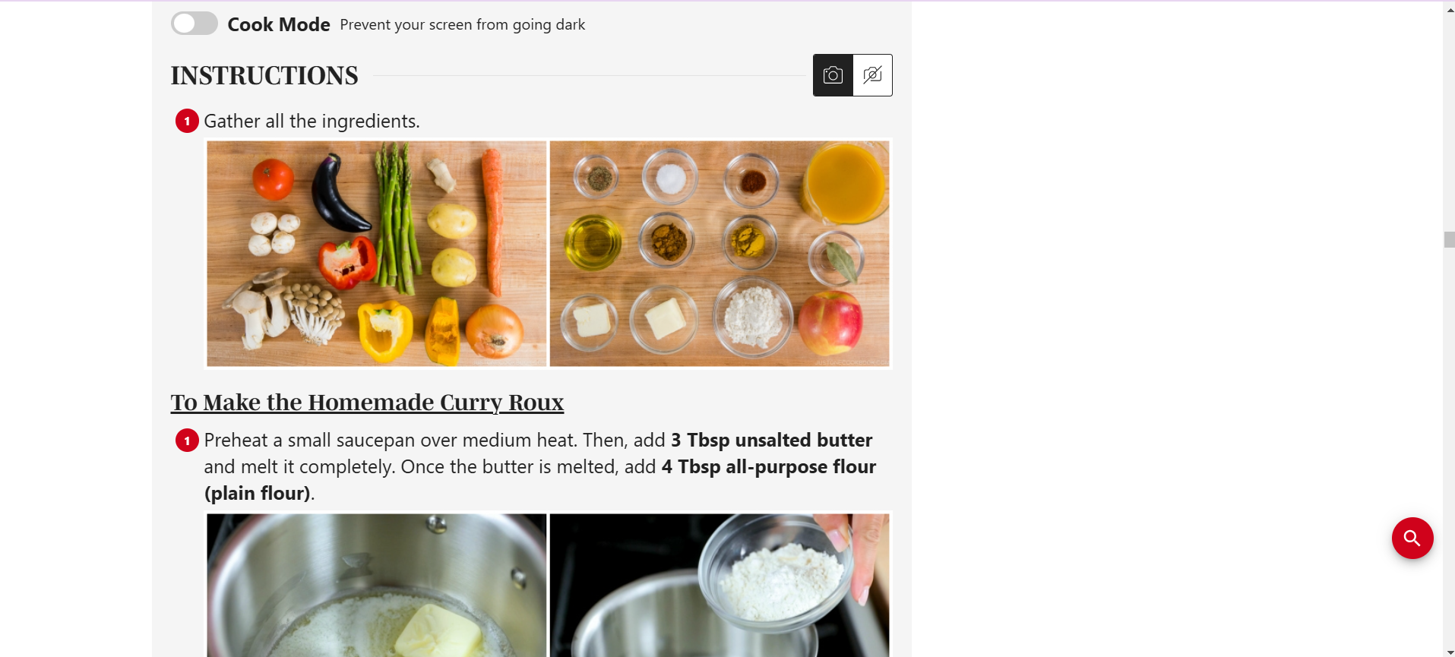

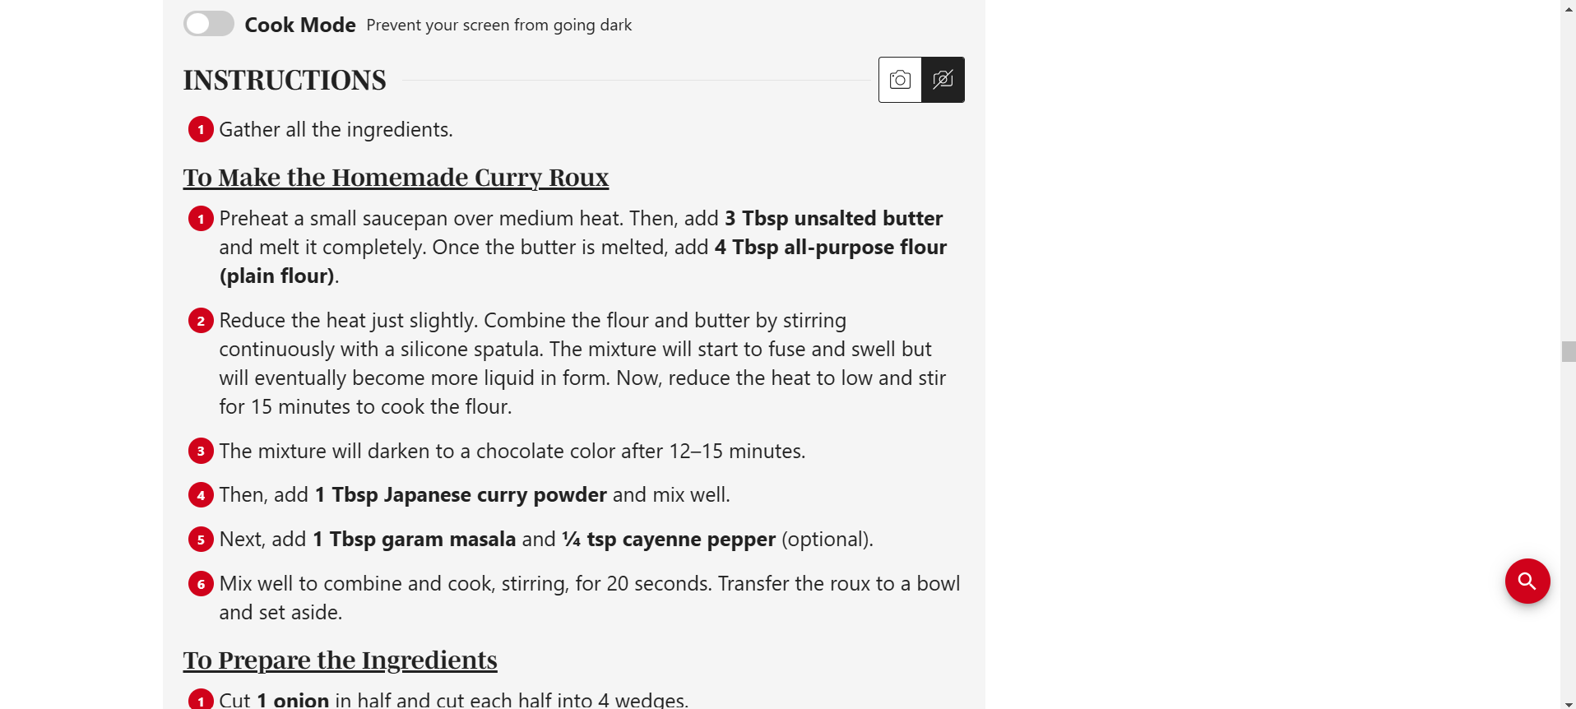

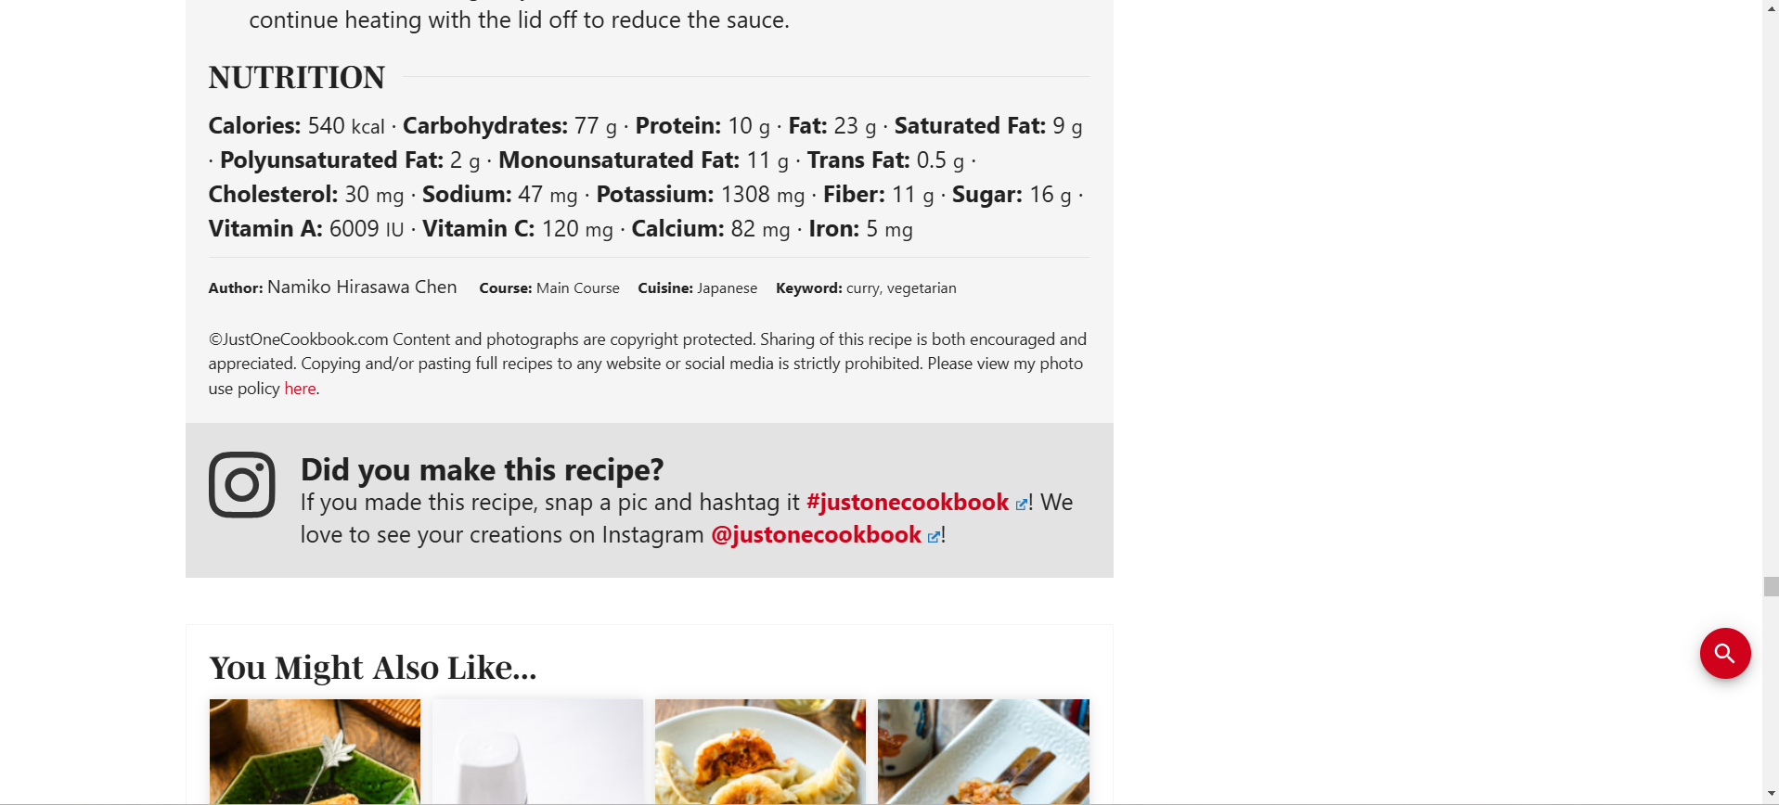

**Minimalist Baker** [**https://minimalistbaker.com/**](https://minimalistbaker.com/)

**Home page:** The layout is organized, modern, has nice pictures and a nice color pallet. The home page is organized starting with simply “Recipes” with some categories, “Pick of the Week” and “Recent Reader Favorites”. Searching for specific recipes or general inspiration is easy because there is a search bar, and all recipes menu option on top, and there are buttons with recipe types/categories below.

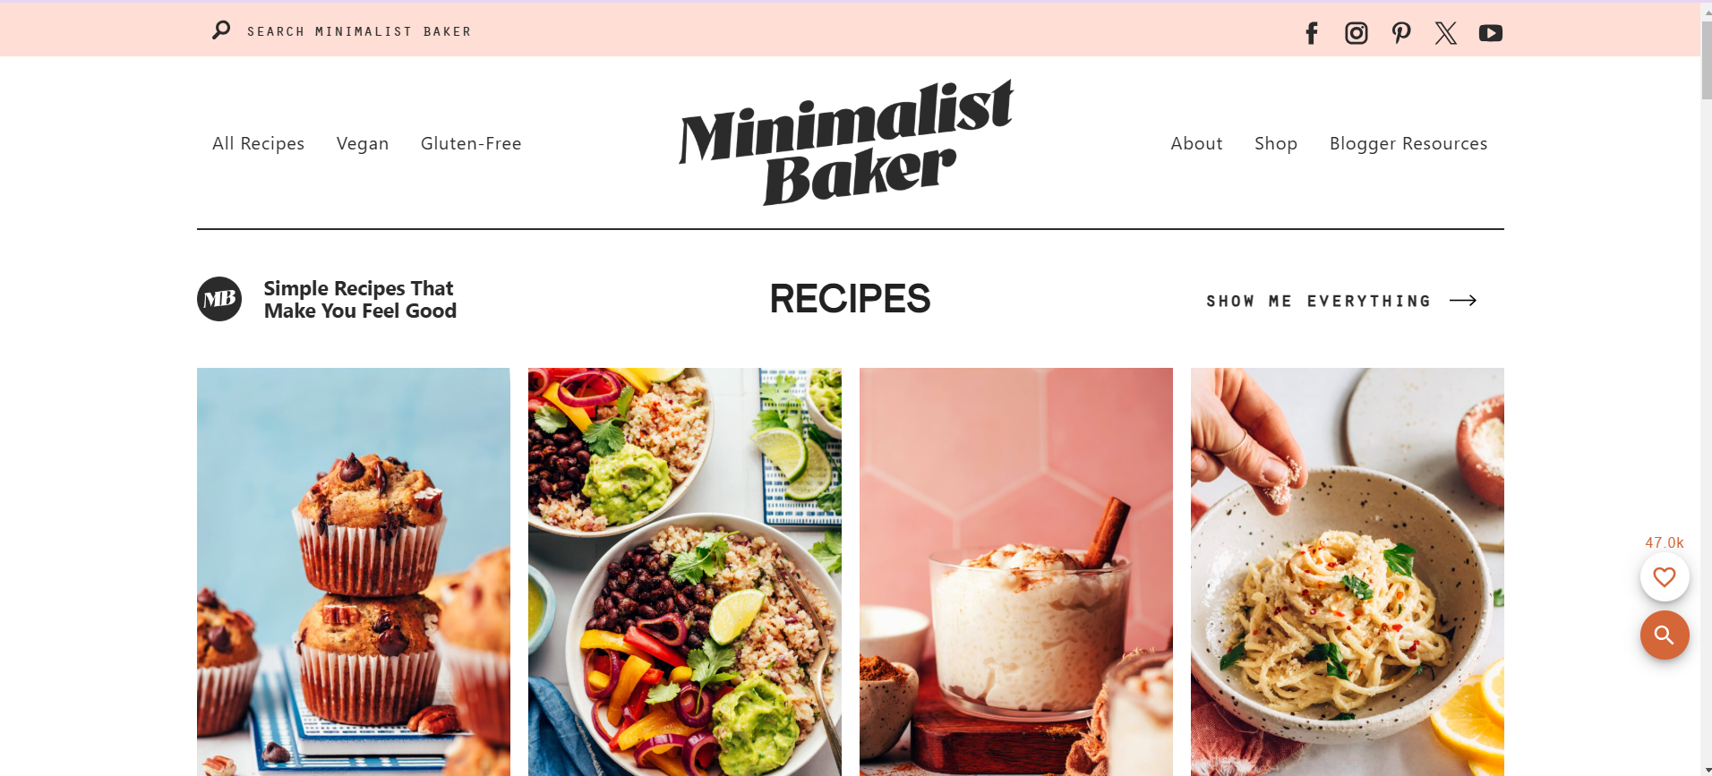

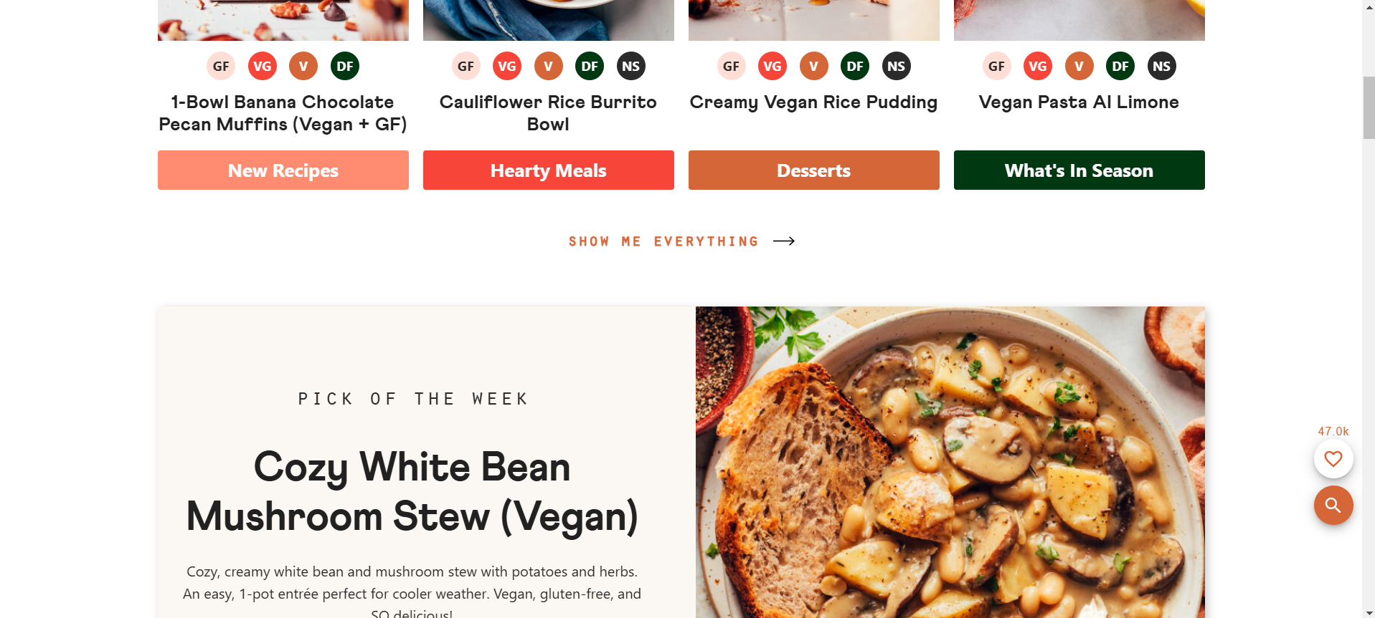

**Recipe page:** The recipe page has a lot of written details and pictures before the actual recipe. Fortunately, there is a jump to recipe button if you want to skip that. There are two different ways to change the serving size, either press the 1x/2x/3x buttons, or slide to change the number next to “Servings” to get more customized measurements. There is a measurement converter from US Customary to Metric. Also, a Cook Mode toggle to prevent your screen from going dark. And there is nutrition information. Also, the recipe key clearly labels the dietary information of the dish (gluten-free, vegan, etc.). The recipe itself is well-written with clear, numbered instructions.

